**Capstone Project Report - The Battle of Neighbourhoods**

**Introduction**

New York City or New York is United State’s most populous city with a population of 8,336,817 spread over 302.6 square miles. New York is also referred to as the financial, cultural and media capital of the world.

New York city demographically is ethnically diverse metropolis and as many as 800 languages are spoken in New York. New York is home to over 3.2 million legal immigrants. Over the past decade, New York city has exponentially grown when compared to its region.

New York city is composed of five boroughs- Brooklyn, Manhattan, Queens, the Bronx and Staten Island.

New York’s food culture influenced by the city’s immigrant history has a wide array of international cuisine hosting world’s finest 1000 restaurants of the world.

With such diverse and rich dining options, the project is aimed at the Indian restaurants in NYC.

Source: Wikipedia/ Google

**Business Problem / Objective of this project**

1. Enlist Indian restaurants in NYC
2. The location with concentrated Indian restaurants
3. Review the rating, tips and additional information associated with these restaurants
4. Rank the restaurants as well as visualise them using Folium
5. The best region to look out for Indian cuisine

**Data Section**

As discussed, New York has a very diverse ethnic population and its food is influenced by the immigrant’s history i.e. you would have Lebanese, Chinese, Indian. Caribbean, Mexican etc. cuisine restaurants.

To perform the above-mentioned analysis, we would need:

* List of Boroughs and Neighbourhood for NYC along with the longitude and latitude details
  + Data source: <https://cocl.us/new_york_dataset>
  + Description:
* Use of FourSquare API to find out the venues of the Indian restaurants in every neighbourhood of New York City.
  + Data Source: FourSquare API
  + Description: Using FourSquare APIs we will get the venues in each neighbourhood which will be further filtered.
* Folium for mapping purposes and visualization

**Approach:**

1. Import all the necessary libraries for getting geographic locations, to create charts, dataframes etc.

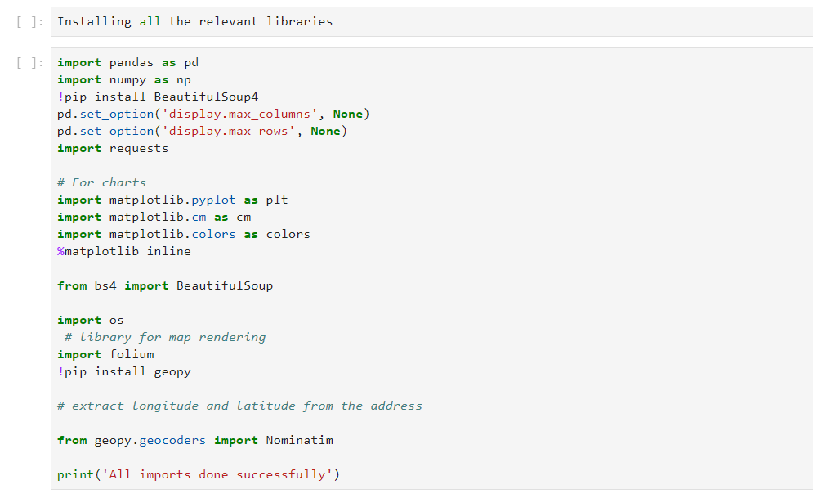

1. Using FourSquare API, get venues from each neighbourhood in NYC

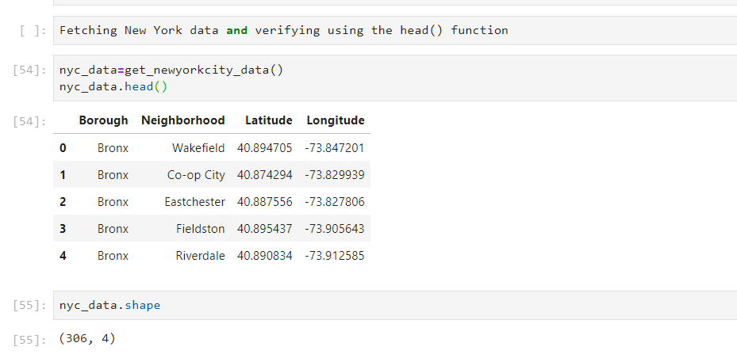

1. Out of all the venues pulled by FourSquare API call, segregate the Indian restaurants

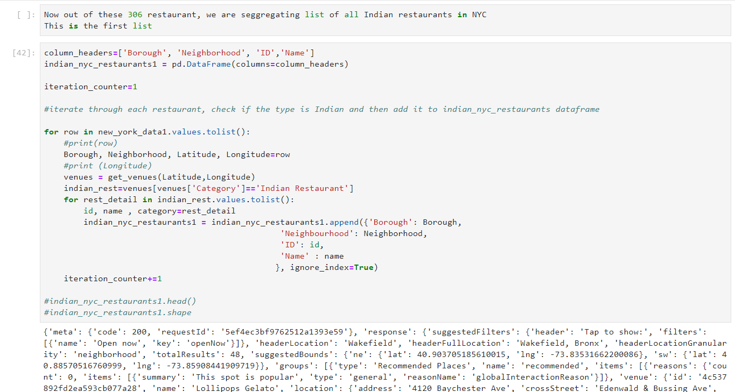

1. Push this list into a CSV file



1. Visualize the concentration of Indian restaurants in each Borough

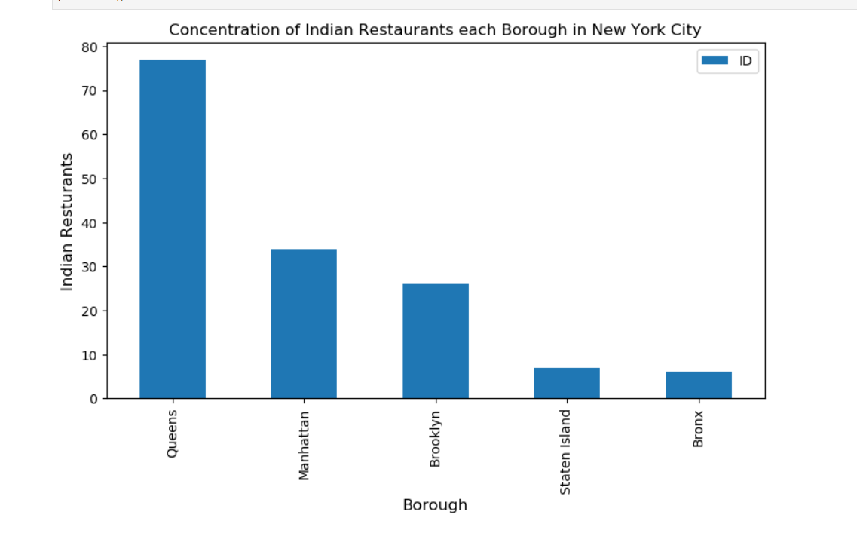

1. Visualize the concentration of Indian restaurants in each neighbourhood

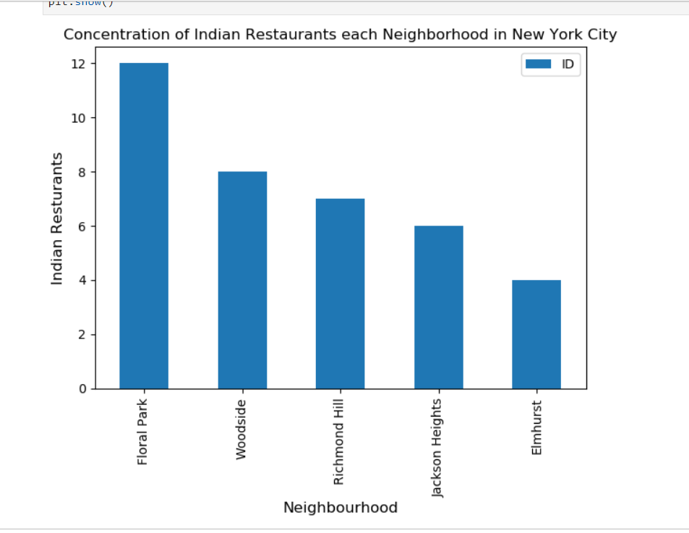

1. Extract the additional ranking details

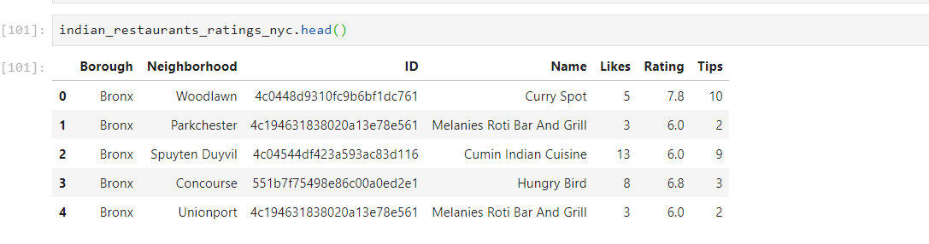

1. The restaurant with the highest rating is

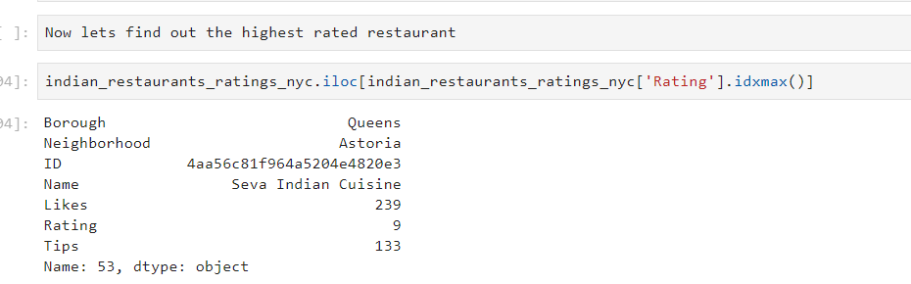

1. The restaurant with maximum likes is

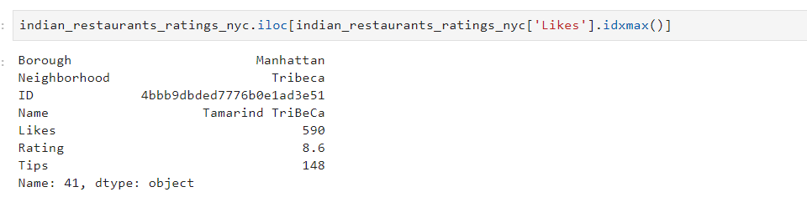

1. The restaurant with maximum tips is

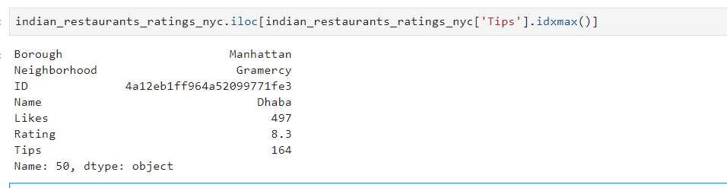

1. Average rating per neighbourhood

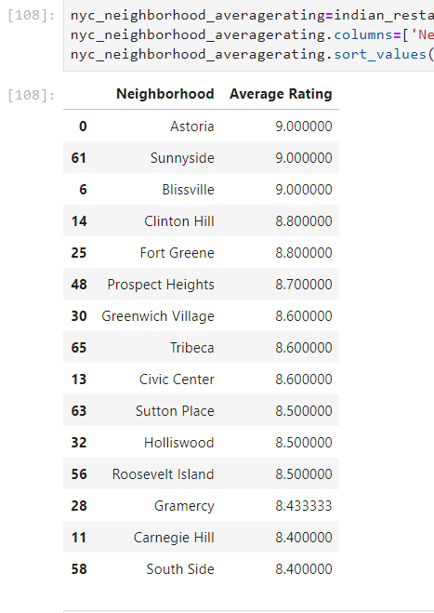

1. Average rating per borough

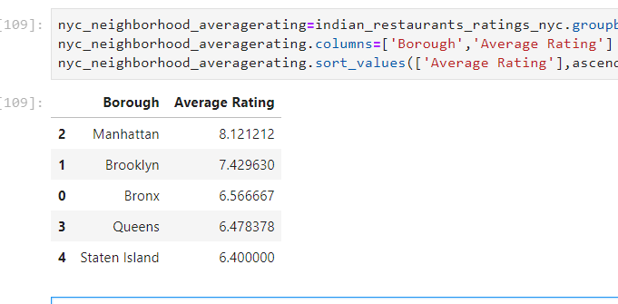

1. The Borough with the best Indian food

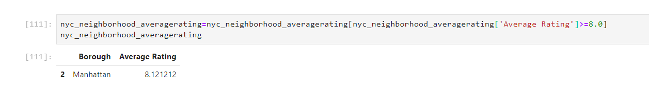

1. Merged the longitude and latitude values with the values in table nyc_data
2. Plotted a map to visualize all the Indian restaurants in NYC

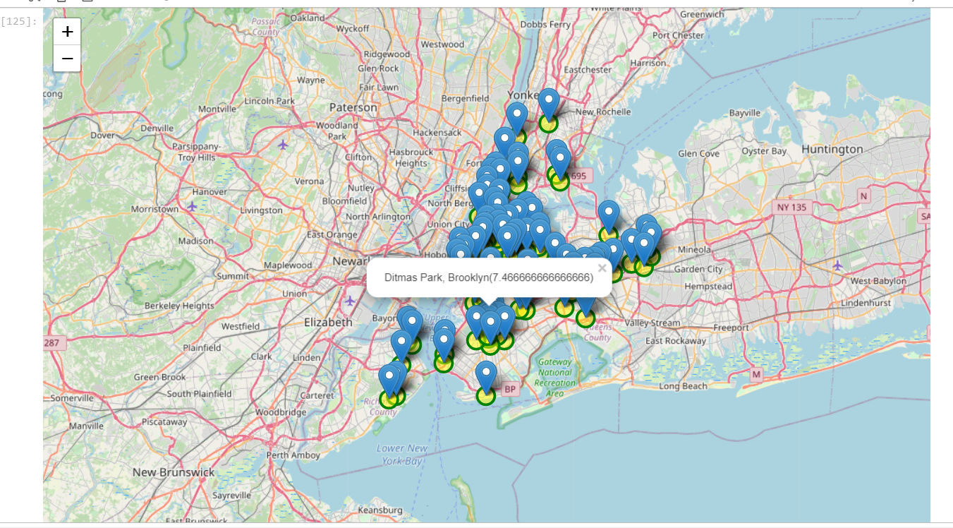

1. Visualize through maps only those neighbourhood with restaurants with average rating above 8.0

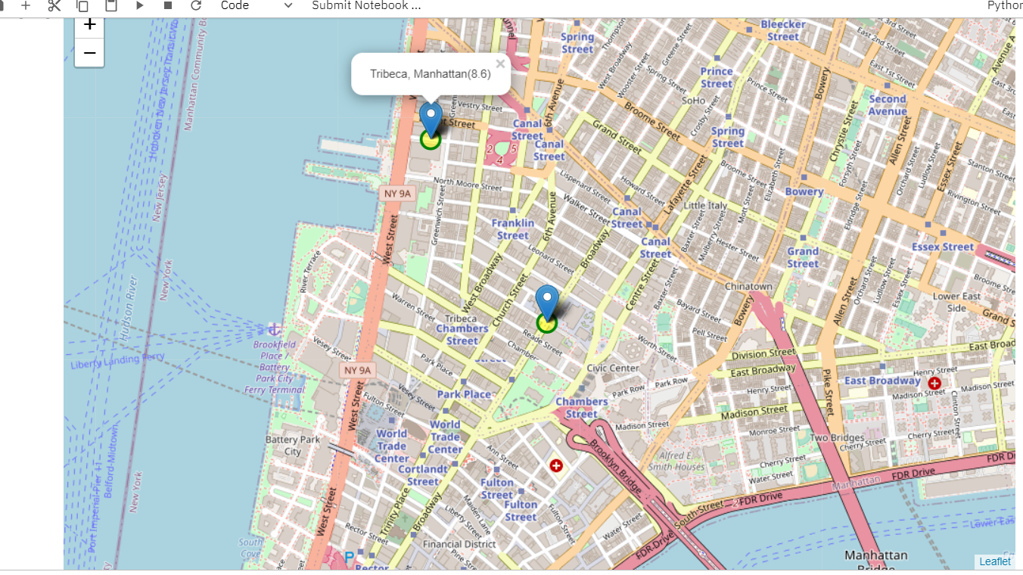

**Conclusions**:

* There are around 360 restaurants in NYC out of which majority are clustered in Queens, followed by Manhattan.
* Neighbourhood wise, Floral Park and Woodside are the most populated regions
* Although Queens has the maximum no. of restaurants, the likes for Manhattan are much higher.
* The best neighbourhood to eat in is Astoria but Manhattan’s Tamarind Tribecca and Dhaba are the best restaurants as per like and tips received
* Staten Island and Bronx borough have food of average quality.
* Astoria, Blissvile and SunnySide are the best neighbourhoods to dine in for Indian cuisine.